We are currently in interregnum.
In the meantime, Helen, Bill, and Lucy head up our Pastoral Support Team
Richard and Brian are our Churchwardens
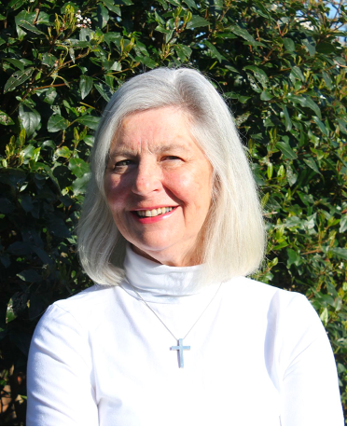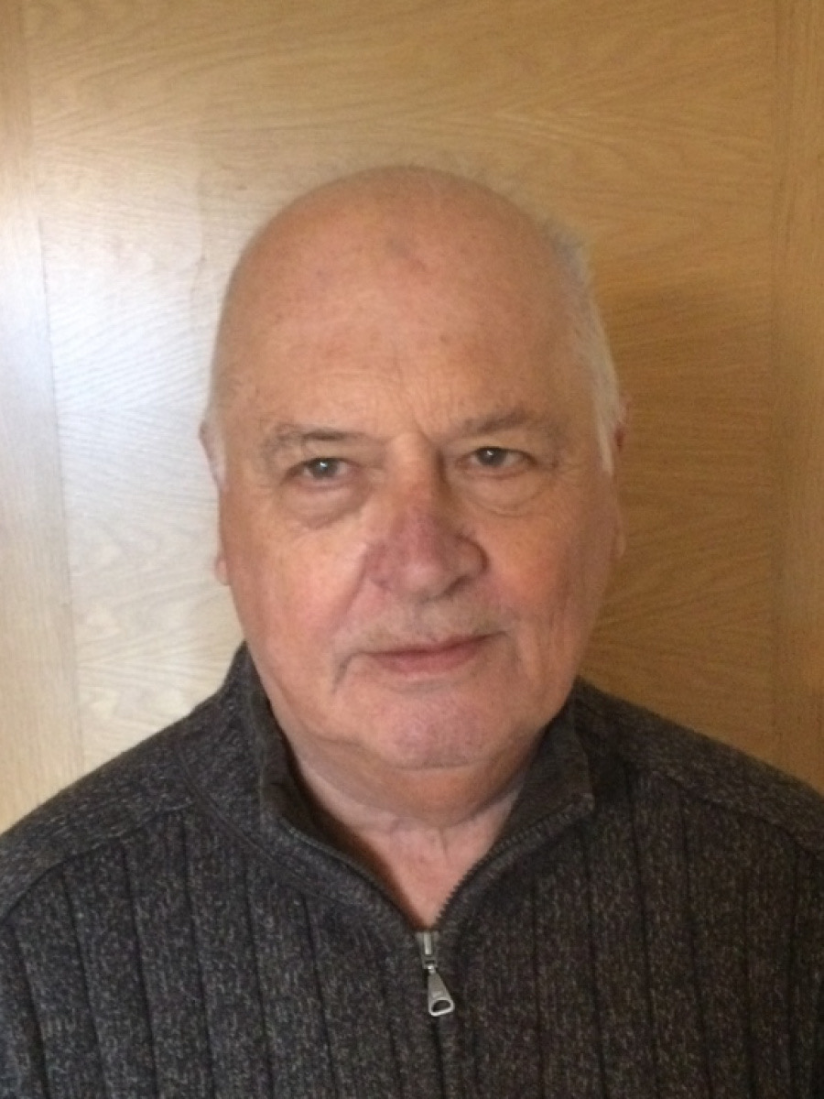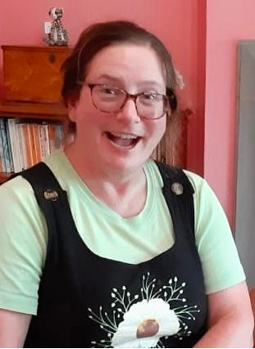

NAME | POSITION | CONTACT
Helen Hunter | Reader | 0151 931 1454
Lucy Faulkner | Pastoral Assistant | 0151 924 5658
Bill Mainey | Reader | 0151 924 9744
Richard Kemp | Church Warden | 0151 932 1053
Brian Dunning | Church Warden | 07784 248808
Jenny Givens | Treasurer | 07568 315892
Chris Rees | Gift Aid Secretary | 0151 931 5797
Beverly Boden | Mothers Union | 0151 924 7450
Sue Kemp | Uniformed  Organisations | 0151 932 1503
Clare Kerrigan | Parish Administrator  & Hall bookings | 0151 924 0561 or  office@stmbsands.org

